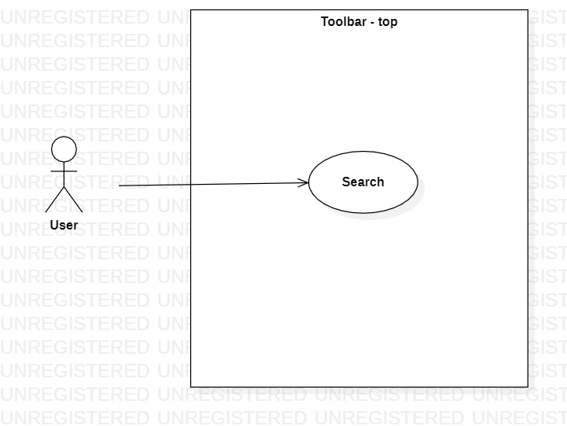

Name: | Search
ID: | 42
Description: | Search resources or tasks by name
Primary Actor: | User
Secondary Actor: | N/A
Preconditions: | N/A
Main Flow: | - User clicks the search bar at the toolbar or presses Ctrl+F  - User types some characters to search for a specific task or resource
Postconditions: | List of tasks or resources whose names match the search input
Alternative flows: | N/A

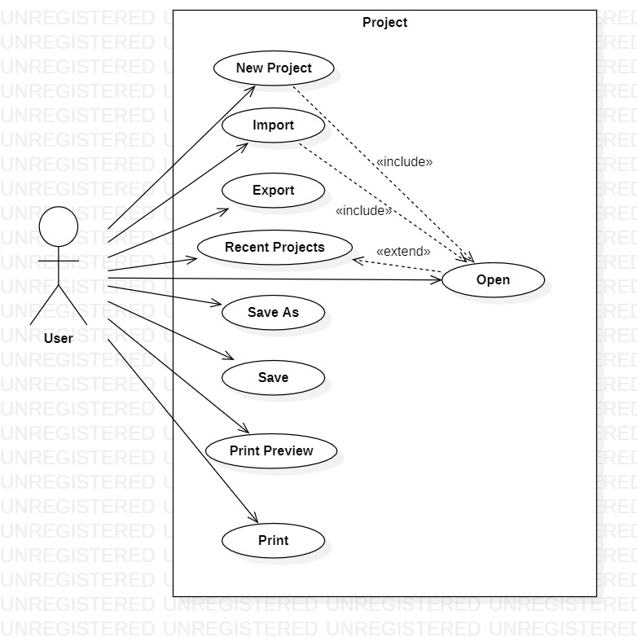

Name: | New Project
ID: | 43
Description: | Creates a new project
Primary Actor: | User
Secondary Actor: | N/A
Preconditions: | N/A
Main Flow: | - User selects New Project under Project or presses Ctrl+N  - User selects the working directory and project name  - User confirms
Postconditions: | Opens a new project
Alternative flows: | Cancel

Name: | Import
ID: | 44
Description: | Imports a project
Primary Actor: | User
Secondary Actor: | N/A
Preconditions: | N/A
Main Flow: | - User selects Import under Project  - User selects an importer  - User selects the file to import  - User confirms
Postconditions: | Opens an existing project
Alternative flows: | Cancel

Name: | Export
ID: | 45
Description: | Exports a project
Primary Actor: | User
Secondary Actor: | N/A
Preconditions: | N/A
Main Flow: | - User selects Import under Project  - User selects an exporter  - User selects the file to export  - User confirms
Postconditions: | Exports project
Alternative flows: | Cancel

Name: | Recent Projects
ID: | 46
Description: | Lists most recent projects
Primary Actor: | User
Secondary Actor: | N/A
Preconditions: | N/A
Main Flow: | - User selects Recent Projects under Project
Postconditions: | A list of recent projects is displayed
Alternative flows: | N/A

Name: | Open
ID: | 47
Description: | Opens a project
Primary Actor: | User
Secondary Actor: | N/A
Preconditions: | N/A
Main Flow: | - User selects Open under Project or presses Ctrl+O  - User selects a project from file explorer  - User confirms
Postconditions: | Opens an existing project
Alternative flows: | Cancel

Name: | Save As
ID: | 48
Description: | Saves a project
Primary Actor: | User
Secondary Actor: | N/A
Preconditions: | N/A
Main Flow: | - User selects Save As under Project or presses Ctrl+Shift+S  - User types a name and selects destination directory  - User confirms
Postconditions: | Saves an existing project
Alternative flows: | Cancel

Name: | Save
ID: | 49
Description: | Saves a project
Primary Actor: | User
Secondary Actor: | N/A
Preconditions: | N/A
Main Flow: | - User selects Save under Project or presses Ctrl+S
Postconditions: | Saves an existing project
Alternative flows: | N/A

Name: | Print Preview
ID: | 50
Description: | Gives a preview of the project as a printable file
Primary Actor: | User
Secondary Actor: | N/A
Preconditions: | N/A
Main Flow: | - User selects Print Preview under Project
Postconditions: | An overall view of the project as a printable file. Can be edited.
Alternative flows: | N/A

Name: | Print
ID: | 51
Description: | Prints a project
Primary Actor: | User
Secondary Actor: | N/A
Preconditions: | N/A
Main Flow: | - User selects Save under Project or presses Ctrl+P  - User selects details for printing  - User confirms
Postconditions: | Project is printed
Alternative flows: | Cancel

